LAPORAN PEMROGRAMAN PERANGKAT BERGERAK
APLIKASI ARISAN



Disusun oleh :
Ervin Ahmad Nur Hidayanto | 4311801010
One Agustiranda | 4311801022

MULTIMEDIA DAN JARINGAN
TEKNIK INFORMATIKA
POLITEKNIK NEGERI BATAM
2020
- Link url acuan (dribbble.com)
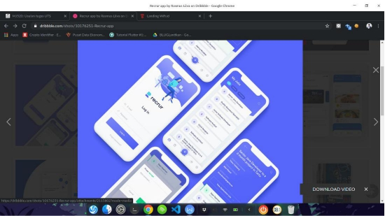
https://dribbble.com/shots/10176251-Recrur-app
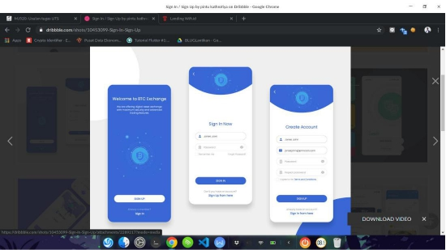
https://dribbble.com/shots/10453099-Sign-In-Sign-Up
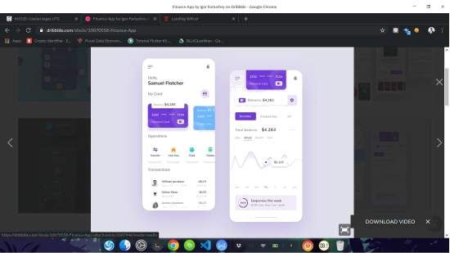
https://dribbble.com/shots/10070558-Finance-App

- Screenshot aplikasi (2-5 halaman)
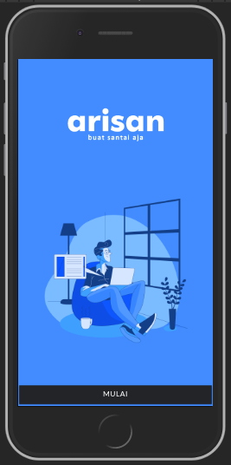 | 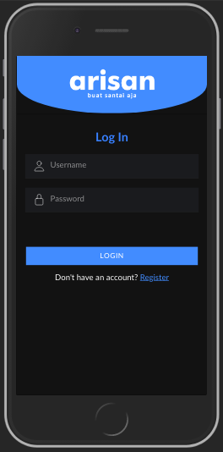 | 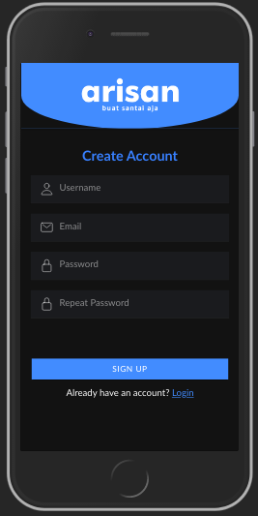
Page Welcome | Page Login | Page Register

- Screenshot aplikasi hasil implementasi disertai kode
Page Welcome
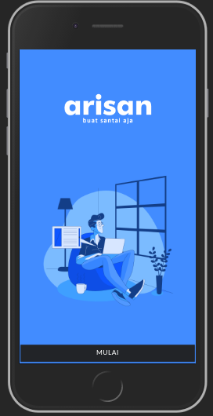 | Html  <ion-content class="padding" color="primary">  <img src="../../assets/icon/logo.png" class="center">  <img src="../../assets/icon/illustrate.png" class="center utama">  <div class="btn-bawah">  <ion-button [routerLink]="['/login']" color="light" expand="full">MULAI</ion-button>  </div>  </ion-content>
Scss
.btn-bawah {
position: fixed;
width: 100%;
bottom: 0px;
}

.center {
display: block;
margin-left: auto;
margin-right: auto;
margin-top: 25%;
width: 50%;
}

.utama {
width: 80%;
height: auto;
}

Page Login
Html

<ion-header>
<ion-toolbar color="primary">
<img src="../../assets/icon/logo.png" class="center">
</ion-toolbar>
</ion-header>
<ion-content class="ion-padding">
<div class="login">
<h2 style="text-align: center;font-weight: bold;color: #3880ff;">Log In</h2>
<ion-item>
<ion-icon name="person-outline"></ion-icon>
<ion-input placeholder="Username"></ion-input>
</ion-item>
<ion-item>
<ion-icon name="lock-closed-outline"></ion-icon>
<ion-input placeholder="Password" type="password"></ion-input>
</ion-item>
<ion-button [routerLink]="['/tabs/tab1']" color="primary" expand="full">LOGIN</ion-button>
<ion-text class="ion-text-center">
<p>Don't have an account? <a [routerLink]="['/register']">Register</a></p>
</ion-text>
</div>
</ion-content>

Scss

ion-icon {
margin-right: 10px;
}
ion-button {
margin-top: 20%;
}
ion-item {
margin-top: 5%;
}
ion-header, ion-toolbar {
border-bottom-left-radius: 50%;
border-bottom-right-radius: 50%;
}
.center {
display: block;
margin-left: auto;
margin-right: auto;
margin-top: 7%;
margin-bottom: 7%;
width: 45%;
}
Page Register
Html

<ion-header>
<ion-toolbar color="primary">
<img src="../../assets/icon/logo.png" class="center">
</ion-toolbar>
</ion-header>
<ion-content class="ion-padding">
<div class="login">
<h2 style="text-align: center;font-weight: bold;color: #3880ff;">Create Account</h2>
<ion-item>
<ion-icon name="person-outline"></ion-icon>
<ion-input placeholder="Username"></ion-input>
</ion-item>
<ion-item>
<ion-icon name="mail-outline"></ion-icon>
<ion-input placeholder="Email"></ion-input>
</ion-item>
<ion-item>
<ion-icon name="lock-closed-outline"></ion-icon>
<ion-input placeholder="Password" type="password"></ion-input>
</ion-item>
<ion-item>
<ion-icon name="lock-closed-outline"></ion-icon>
<ion-input placeholder="Repeat Password" type="password"></ion-input>
</ion-item>
<ion-button [routerLink]="['/tabs']" color="primary" expand="full">SIGN UP</ion-button>
<ion-text class="ion-text-center">
<p>Already have an account? <a [routerLink]="['/login']">Login</a></p>
</ion-text>
</div>
</ion-content>

Scss

ion-icon {
margin-right: 10px;
}
ion-button {
margin-top: 20%;
}
ion-item {
margin-top: 5%;
}
ion-toolbar {
border-bottom-left-radius: 50%;
border-bottom-right-radius: 50%;
}
.center {
display: block;
margin-left: auto;
margin-right: auto;
margin-top: 7%;
margin-bottom: 7%;
width: 45%;
}

Page Tab1
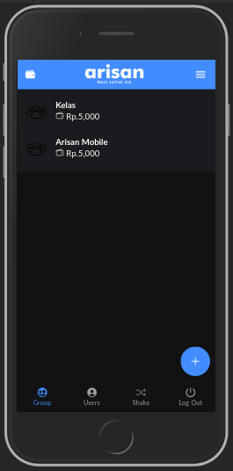 | Html  <ion-header [translucent]="true" color="primary">  <ion-toolbar color="primary">  <ion-buttons slot="start">  <ion-button>  <ion-icon name="wallet"></ion-icon>  </ion-button>  </ion-buttons>  <ion-buttons slot="end">  <ion-menu-button auto-hide="false"></ion-menu-button>  </ion-buttons>  <img src="../../assets/icon/logo.png" class="center">  <!--<ion-title><b>Arisan</b> | Group</ion-title>-->  </ion-toolbar>  </ion-header>  <ion-content [fullscreen]="true">  <ion-refresher slot="fixed" (ionRefresh)="doRefresh($event)">  <ion-refresher-content pullingIcon="arrow-dropdown" pullingText="Pull to refresh" refreshingSpinner="circles" refreshingText="Refreshing...">  </ion-refresher-content>  </ion-refresher>  <ion-list>  <ion-item-sliding *ngFor="let group of groups" id="item100">  <ion-item (click)="goDetail(group)">  <ion-avatar slot="start">  <img src="../../assets/icon/group.png">  </ion-avatar>  <ion-label>  <h2><b>{{group.name}}</b></h2>  <h2><ion-icon name="wallet-outline"></ion-icon> Rp.{{group.amount | number : fractionSize}}</h2>  <p></p>  </ion-label>  </ion-item>  <ion-item-options side="start">  <ion-item-option color="danger" (click)="delete(group)">  <ion-icon slot="icon-only" name="trash"></ion-icon>  </ion-item-option>  </ion-item-options>  <ion-item-options side="end">  <ion-item-option color="success">  <ion-icon slot="icon-only" name="checkmark-circle"></ion-icon>  </ion-item-option>  </ion-item-options>  </ion-item-sliding>  </ion-list>  <ion-fab vertical="bottom" horizontal="end" slot="fixed">  <ion-fab-button (click)="goAdd()">  <ion-icon name="add"></ion-icon>  </ion-fab-button>  </ion-fab>  </ion-content>
Scss

ion-content ion-toolbar {
--background: translucent;
}

.center {
display: block;
margin-left: auto;
margin-right: auto;
margin-top: 2%;
margin-bottom: 2%;
width: 40%;
}

Page add group
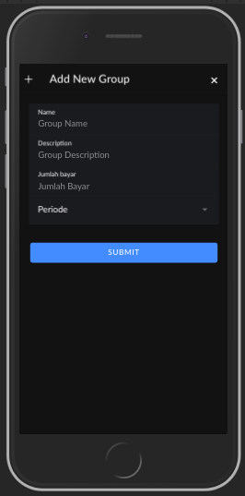 | Html  <ion-header>  <ion-toolbar>  <ion-buttons slot="start">  <ion-icon slot="start" name="add"></ion-icon>  </ion-buttons>  <ion-title>Add New Group</ion-title>  <ion-buttons slot="end">  <ion-button (click)="closePage()">  <ion-icon name="close"></ion-icon>  </ion-button>  </ion-buttons>  </ion-toolbar>  </ion-header>  <ion-content class="ion-padding">  <ion-item>  <ion-label position="stacked">Name</ion-label>  <ion-input [(ngModel)]="group.name" placeholder="Group Name"></ion-input>  </ion-item>  <ion-item>  <ion-label position="stacked">Description</ion-label>  <ion-input [(ngModel)]="group.desc" placeholder="Group Description"></ion-input>  </ion-item>  <ion-item>  <ion-label position="stacked">Jumlah bayar</ion-label>  <ion-input [(ngModel)]="group.amount" type="number" placeholder="Jumlah Bayar"></ion-input>  </ion-item>  <ion-item>  <ion-label>Periode</ion-label>  <ion-select value="10" [(ngModel)]="group.period">  <ion-select-option value="10">10 hari</ion-select-option>  <ion-select-option value="20">20 hari</ion-select-option>  <ion-select-option value="30">30 hari</ion-select-option>  </ion-select>  </ion-item>  <ion-button expand="block" (click)="submit()">SUBMIT</ion-button>  </ion-content>
Scss

ion-button {
margin-top: 10%;
}

Page Group Description
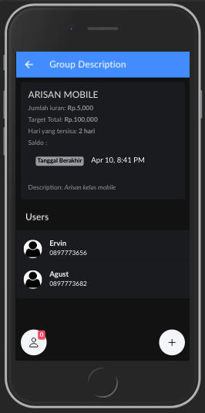 | Html  <ion-header>  <ion-toolbar color="primary">  <ion-buttons slot="start">  <ion-back-button defaultHref="/tabs/tab1"></ion-back-button>  </ion-buttons>  <ion-title>Group Description</ion-title>  <ion-buttons slot="end">  <ion-button (click)="goEdit()">  <ion-icon name="create"></ion-icon>  </ion-button>  </ion-buttons>  </ion-toolbar>  </ion-header>  <ion-content>  <ion-card>  <ion-card-header>  <ion-card-title>{{group.name | uppercase}}</ion-card-title>  <ion-card-subtitle>Jumlah iuran: <b>Rp.{{group.amount | number : fractionSize}}</b> </ion-card-subtitle>  <ion-card-subtitle>Target Total: <b>Rp.{{group.amount * group.period * users.length | number : fractionSize}}</b> </ion-card-subtitle>  <ion-card-subtitle>Hari yang tersisa: <b> {{dayRemaining}} hari</b> </ion-card-subtitle>  <ion-card-subtitle>Saldo : <b> </b> </ion-card-subtitle>  <ion-item>  <ion-badge color="medium">Tanggal Berakhir</ion-badge>  <ion-label><ion-datetime displayFormat="MMM DD, h:mm A" [(ngModel)]="group.endDate"></ion-datetime></ion-label>  </ion-item>  </ion-card-header>  <ion-card-content>  <p>Description: <i>{{group.desc}}</i></p>  </ion-card-content>  </ion-card>  <ion-toolbar>  <ion-title>Users</ion-title>  </ion-toolbar>  <ion-list>  <ion-item-sliding *ngFor="let user of users" id="item100">  <ion-item href="#">  <ion-avatar slot="start">  <img src="../../assets/img/user.png">  </ion-avatar>  <ion-label>  <h2><b>{{user.fullname}}</b></h2>  <h3>{{user.no_telp}}</h3>  <p>{{user.group}}</p>  </ion-label>  </ion-item>  <ion-item-options side="start">  <ion-item-option color="danger">  <ion-icon slot="icon-only" name="trash"></ion-icon>  </ion-item-option>  </ion-item-options>  <ion-item-options side="end">  <ion-item-option color="success">  <ion-icon slot="icon-only" name="checkmark-circle"></ion-icon>  </ion-item-option>  </ion-item-options>  </ion-item-sliding>  </ion-list>  <ion-fab vertical="bottom" horizontal="end" slot="fixed">  <ion-fab-button color="dark" (click)="AddUser(group)">  <ion-icon name="add"></ion-icon>  </ion-fab-button>  </ion-fab>  <ion-fab horizontal="start" vertical="bottom" slot="fixed">  <ion-badge color="danger" id="notifications-badge">{{usersUnpaid.length}}</ion-badge>  <ion-fab-button color="dark" (click)="ShowUnpaidUser(group)" id="notification-button">  <ion-icon name="person-outline"></ion-icon>  </ion-fab-button>  </ion-fab>  </ion-content>
Scss

ion-fab{
ion-badge {
z-index: 1;
position: absolute;
top: 0.1rem;
right: 0.2rem;
& ~ ion-icon {
margin-right: 1.2rem;
}
}
}

Page Add User
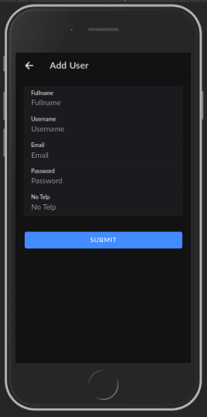 | Html  <ion-header>  <ion-toolbar>  <ion-buttons slot="start">  <ion-back-button defaultHref="/group-detail/{{groupId}}"></ion-back-button>  </ion-buttons>  <ion-title>Add User</ion-title>  </ion-toolbar>  </ion-header>  <ion-content class="ion-padding">  <ion-item>  <ion-label position="stacked">Fullname</ion-label>  <ion-input [(ngModel)]="users.fullname" placeholder="Fullname"></ion-input>  </ion-item>  <ion-item>  <ion-label position="stacked">Username</ion-label>  <ion-input [(ngModel)]="users.username" type="text" placeholder="Username"></ion-input>  </ion-item>  <ion-item>  <ion-label position="stacked">Email</ion-label>  <ion-input [(ngModel)]="users.email" type="text" placeholder="Email"></ion-input>  </ion-item>  <ion-item>  <ion-label position="stacked">Password</ion-label>  <ion-input [(ngModel)]="users.password" type="text" placeholder="Password"></ion-input>  </ion-item>  <ion-item>  <ion-label position="stacked">No Telp</ion-label>  <ion-input [(ngModel)]="users.no_telp" type="text" placeholder="No Telp"></ion-input>  </ion-item>  <ion-button expand="block" (click)="submit()">SUBMIT</ion-button>  </ion-content>
Scss

ion-button {
margin-top: 10%;
}

Page Tab2
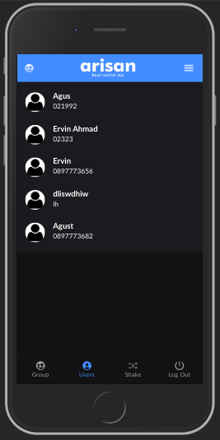 | Html  <ion-header [translucent]="true" color="primary">  <ion-toolbar color="primary">  <ion-buttons slot="start">  <ion-button>  <ion-icon name="people-circle"></ion-icon>  </ion-button>  </ion-buttons>  <ion-buttons slot="end">  <ion-menu-button auto-hide="false"></ion-menu-button>  </ion-buttons>  <img src="../../assets/icon/logo.png" class="center">  <!--<ion-title><b>Arisan</b> | Users</ion-title>-->  </ion-toolbar>  </ion-header>  <ion-content [fullscreen]="true">  <ion-list>  <ion-item-sliding *ngFor="let user of users" id="item100">  <ion-item href="#">  <ion-avatar slot="start">  <img src="../../assets/img/user.png">  </ion-avatar>  <ion-label>  <h2><b>{{user.fullname}}</b></h2>  <h3>{{user.no_telp}}</h3>  <p>{{user.group}}</p>  </ion-label>  </ion-item>  <ion-item-options side="start">  <ion-item-option color="danger">  <ion-icon slot="icon-only" name="trash"></ion-icon>  </ion-item-option>  </ion-item-options>  <ion-item-options side="end">  <ion-item-option color="success">  <ion-icon slot="icon-only" name="checkmark-circle"></ion-icon>  </ion-item-option>  </ion-item-options>  </ion-item-sliding>  </ion-list>  </ion-content>
Scss

ion-content ion-toolbar {
--background: translucent;
}

.center {
display: block;
margin-left: auto;
margin-right: auto;
margin-top: 2%;
margin-bottom: 2%;
width: 40%;
}

Page Tab3
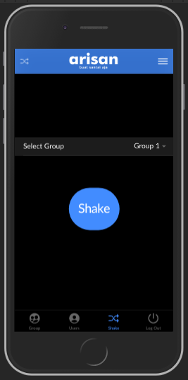 | Html  <ion-header [translucent]="true" color="primary">  <ion-toolbar color="primary">  <ion-buttons slot="start">  <ion-button>  <ion-icon name="shuffle"></ion-icon>  </ion-button>  </ion-buttons>  <ion-buttons slot="end">  <ion-menu-button auto-hide="false"></ion-menu-button>  </ion-buttons>  <img src="../../assets/icon/logo.png" class="center">  </ion-toolbar>  </ion-header>  <ion-content [fullscreen]="true">  <ion-item style="margin-top: 40%;">  <ion-label>Select Group</ion-label>  <ion-select value="brown" okText="Okay" cancelText="Dismiss">  <ion-select-option value="brown">Group 1</ion-select-option>  <ion-select-option value="blonde">Group 2</ion-select-option>  <ion-select-option value="black">Group 3</ion-select-option>  <ion-select-option value="red">Group 4</ion-select-option>  </ion-select>  </ion-item>  <div style="text-align: center;">  <ion-button shape="round" class="shake">Shake</ion-button>  </div>  </ion-content>
Scss

ion-content ion-toolbar {
--background: translucent;
}

.center {
display: block;
margin-left: auto;
margin-right: auto;
margin-top: 2%;
margin-bottom: 2%;
width: 40%;
}
.shake{
margin-top: 20%;
width: 120px;
height: 100px;
font-size: 30px;
}

